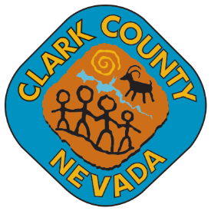
NAME OF TAB/CAC
Site Location
Site Address
City, State, Zip
June 15, 2016
7:30 p.m.

Board Members: Member – Chair Member - Vice Chair
Member Member Member

Secretary: name, phone, email

Town Liaison: name, phone, email

MEETING CANCELLED
DUE TO
Choose an item.

The next scheduled meeting will be held on
January 19, 2017 at 6:30 pm
unless otherwise posted.

POSTING LOCATIONS: This meeting was legally noticed and posted at the following locations:
Posting location and address
Posting location and address
Posting location and address
Posting location and address
https://notice.nv.gov/

